QAComplete Pre-Upgrade Questionnaire ^{revision date: 10/03/2017}
To ensure a successful upgrade experience, please take a moment to review and fill in the information below. Your responses will help us provide the proper upgrade media and allow us to assist you most effectively in completing this task.

- Do you have multiple application instances to upgrade (i.e. a Test instance and a Production instance)?
If you do, please answer questions below with this in mind and note significant differences in the two environments.

- What version are you currently on (ex: version 11.0 build 11.0.101)?
As a reply, please send us a screenshot of the “Setup and Administration” area. Example:
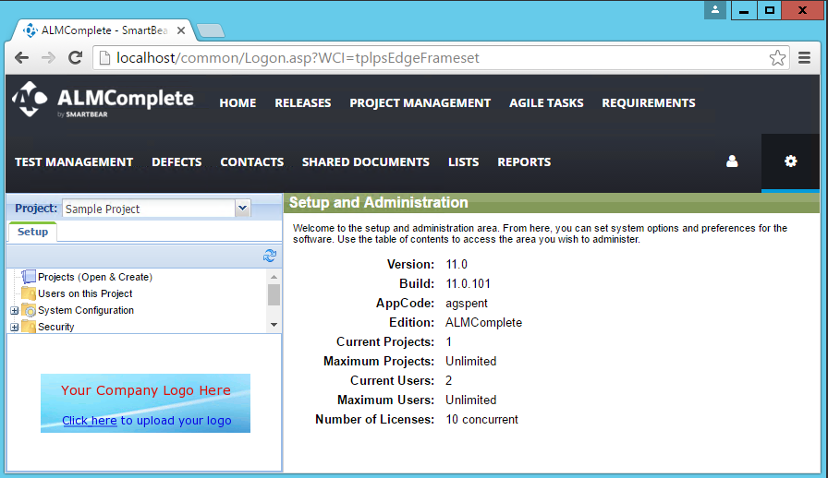
- Do you use one of ALMComplete-specific or legacy modules below and want to continue using them after the upgrade?
  - Project Management;
  - Support Ticket Management;
  - Discussion Forums;
  - Contact Management;
  - Calendar Management;
  - Test Cases.

- What version of the Windows Server application is installed?

- What version of SQL Server is used to host the application databases?

- Are QAC Application Server and Database Server on the same machine?

- Does the application use the Default Web Site in IIS (Internet Information Services)?
Example:
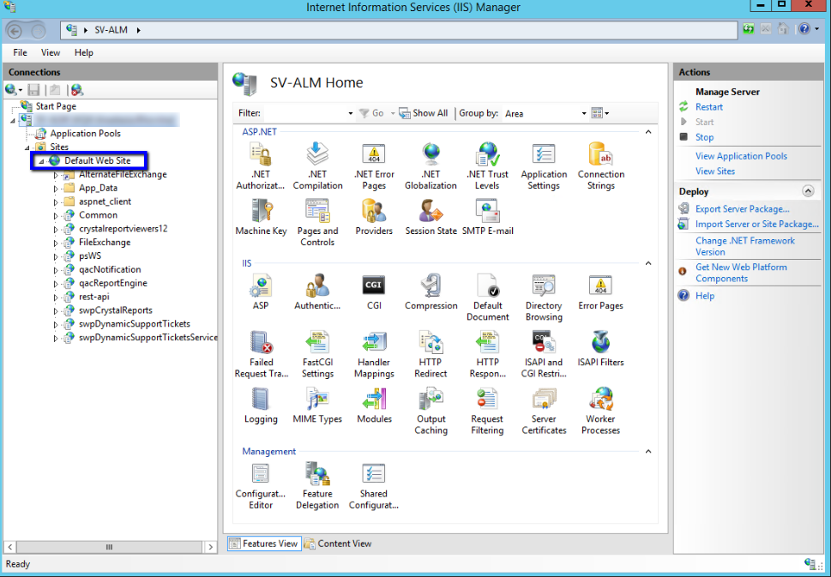

- In case of the Default Web Site, is its Physical Path default (C:\inetpub\wwwroot) or not?
Example:
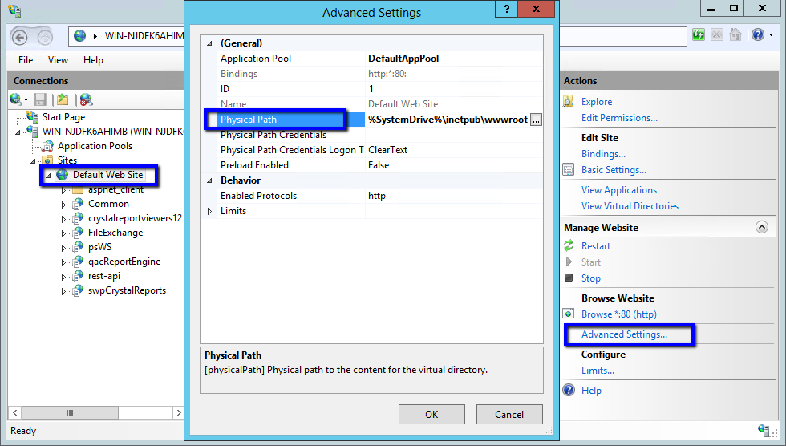

- Are application components installed to the default directory, which is “C:\Program Files (x86)\SmartBear”?

- Do you use an alternate directory (“AlternateFileExchange”) to hold your attachments?
Example:
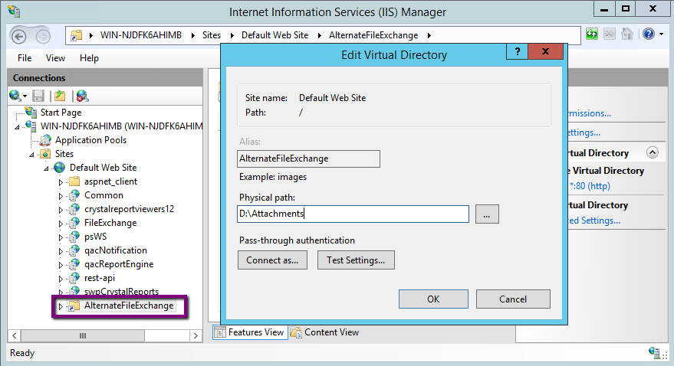
- Do you have custom Crystal Reports?

- Is the application configured to use Active Directory Authentication?

- Do you restrict any security protocols on the Application and/or DB server?
Note that QAC 11.5 and earlier require TLS 1.0 to be enabled during the upgrade on both Application and DB Servers.

- Do you use QAC-Jira Connector, Test Agent, OpsHub, Automated Testing Bridge, or MS Project Plugin to integrate the application with other tools?

- What is the timeframe in which you hope to complete the upgrade?

